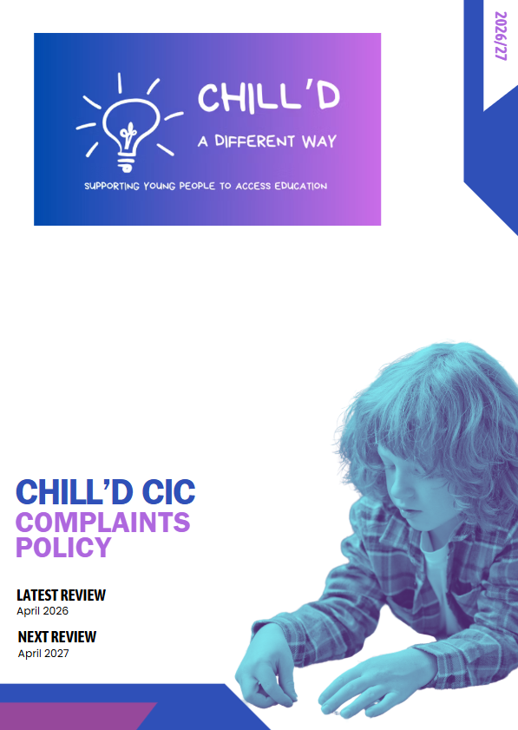
Complaints Policy
This document outlines the complaints policy for Chill’d CIC, ensuring that all stakeholders understand the process for raising concerns and the steps taken to address them. The aim is to provide a clear and transparent framework that promotes accountability, encourages feedback, and fosters improvement in the quality of education and support provided to students.
Purpose of the Policy
The purpose of this complaints policy is to ensure that all complaints are handled fairly, consistently, and in a timely manner. It is essential that students and parents/carers feel empowered to voice their concerns, knowing that they will be taken seriously and addressed appropriately.
Scope
This policy applies to all students accessing provision with Chill’d CIC, their parents /carers, and staff members. It covers complaints related to educational provision, staff conduct, safety, and any other issues that may arise within the setting.
Complaints Procedure
Step 1: Informal Resolution
- Initial Discussion: We encourage complainants to discuss their concerns informally with the relevant staff member. This could be a tutor, support staff, DSL or the designated complaints officer.
- Resolution: Many issues can be resolved at this stage through open communication and dialogue.
Step 2: Formal Complaint
If the issue is not resolved informally, the complainant may submit a formal complaint in writing. The complaint should include:
- The complainant's name and contact details
- A clear description of the complaint
- Any relevant dates or incidents
- Desired outcome or resolution
Step 3: Acknowledgment
Upon receiving a formal complaint, Chill’d CIC will acknowledge receipt within five working days. This acknowledgment will include information about the next steps in the complaints process.
Step 4: Investigation
The complaint will be investigated by an appropriate member of staff who is not directly involved in the matter. The investigation will include:
- Gathering relevant information and evidence
- Speaking with the complainant and any witnesses
- Reviewing any relevant documentation
Step 5: Outcome
Once the investigation is complete, the complainant will receive a written response detailing the findings and any actions taken. This response will be provided within 20 working days of the formal complaint being acknowledged.
Step 6: Further Action
If the complainant is not satisfied with the outcome, they may escalate the complaint to the governing body or an external agency, depending on the nature of the complaint. Information on how to escalate the complaint will be included in the response.
Confidentiality
All complaints will be treated with confidentiality and sensitivity. Information will only be shared with those directly involved in the investigation and resolution of the complaint.
Monitoring and Review
This complaints policy will be reviewed annually to ensure its effectiveness and relevance. Feedback from stakeholders will be considered in the review process to continuously improve the complaints handling procedure.
Conclusion
This complaints policy is designed to ensure that all concerns raised within are addressed promptly and effectively. By fostering a culture of openness and accountability, we aim to enhance the educational experience for all students and maintain high standards of provision.

