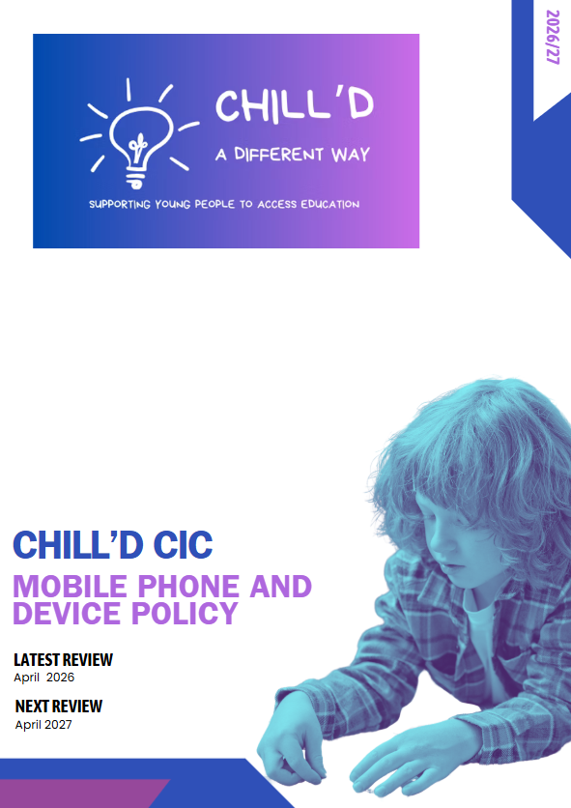

1. Introduction
Chill’d CIC recognises that mobile phones and smart watches are increasingly prevalent in students' lives. While these devices can offer potential benefits, such as facilitating communication and providing access to information, their misuse can disrupt learning, compromise student safety, and contribute to social issues like cyberbullying. This policy aims to provide clear guidelines on our approach to the use of mobile phones and smart watches.
2. Policy Objectives
This policy aims to:
- Promote a focused and productive learning environment.
- Safeguard students from potential risks associated with mobile phone and smart watch use, including cyberbullying, inappropriate content, and exploitation.
- Encourage positive social interaction and communication skills.
- Ensure equitable access to learning opportunities for all students.
- Provide clarity and consistency for students, staff, and parents/carers regarding expectations for mobile phone and smart watch use.
3. Definitions
- Mobile Phone: Any portable electronic device capable of making and receiving calls, sending and receiving text messages, and accessing the internet.
- Smart Watch: A wearable electronic device with functionalities similar to a mobile phone, including communication, internet access, and data storage.
- Premises: All buildings, grounds, and facilities under the control of Chill’d CIC.
- Designated Staff: Staff members authorised to manage mobile phone and smart watch related issues, as determined by the head of centre.
4. General Principles
- Respect and Responsibility: Students are not permitted to use mobile phones and smart watches during the delivery of provision at Chill’d CIC.
- Safeguarding: The safety and well-being of students are paramount and Chill’d CIC deem the risk too high for students to be using them during provision.
- Equality: All students will be treated fairly and equitably regarding mobile phone and smart watch use.
- Parental/Carer Support: We encourage parents/carers to support the policy and work with us to promote our stance of the use of mobile phones and smart watches.

5. Permitted Use
- Before and After Provision: Students are not permitted to use mobile phones or smart watches during the provision day, including break times, unless permission has been given by staff for a specific educational, safeguarding, medical, or individual need. Any devices brought into provision must remain switched off and stored securely until the end of the session. Reasonable adjustments may be made where device use forms part of an agreed support plan, EHCP provision, communication need, sensory regulation strategy, or medical requirement.
- Educational Purposes: Mobile phones and smart watches may be used for educational purposes during lessons with the explicit permission and under the direct supervision of the tutor. This may include accessing online resources, using educational apps, or participating in interactive learning activities.
- Emergency Situations: In genuine emergency situations, students may use their mobile phones or smart watches to contact parents/carers or emergency services. They should inform a member of staff as soon as possible.
6. Prohibited Use
The following uses of mobile phones and smart watches are strictly prohibited on Chill’d CIC premises:
- During Lessons (without permission): Using mobile phones or smart watches during lessons without the explicit permission and supervision of the tutor.
- In Examinations: Using mobile phones or smart watches during examinations or assessments.
- In Changing Rooms and Toilets: Using mobile phones or smart watches in changing rooms or toilets.
- Taking Photographs or Videos: Taking photographs or videos of students or staff without their explicit consent.
- Cyberbullying: Engaging in cyberbullying, harassment, or any form of online abuse.
- Accessing Inappropriate Content: Accessing, viewing, or sharing inappropriate content, including pornography, violent material, or content that promotes discrimination or hatred.
- Recording Conversations: Recording conversations without the knowledge and consent of all parties involved.
- Making or Receiving Calls During Lessons: Making or receiving personal calls during lessons without the permission of the teacher.
- Selling or Trading: Using mobile phones or smart watches for selling or trading goods or services.
7. Storage and Security
- Responsibility: Students are responsible for the security of their own mobile phones and smart watches. Chill’d CIC is not responsible for loss, theft, or damage to these devices.
- Secure Storage: When mobile phones and smart watches are not permitted for use, they should be switched off and stored securely in bags or lockers.
- Confiscation: If a student is found using a mobile phone or smart watch in violation of this policy, the device may be confiscated by a member of staff.
8. Consequences of Policy Violation
Violation of this policy may result in the following consequences:
- Verbal Warning: A verbal warning from a member of staff.
- Confiscation of Device: Confiscation of the mobile phone or smart watch. The device will be returned to the student at the end of the school day or to a parent/carer.
- Detention: Detention for a specified period.
- Parent/Carer Contact: Contacting the student's parents/carers to inform them of the violation.
- Suspension: Suspension from Chill’d CIC for a specified period.
- Withdrawal: In cases of serious or repeated violations, withdrawal from Chill’d CIC may be considered.
The severity of the consequence will depend on the nature and severity of the violation, as well as the student's previous disciplinary record.
9. Staff Responsibilities
- Enforcement: Staff members are responsible for enforcing this policy consistently and fairly.
- Education: Staff members should educate students about the responsible use of mobile phones and smart watches upon their induction.
- Reporting: Staff members should report any violations of this policy to the Designated Staff.
- Support: Staff members should provide support to students who are struggling to comply with this policy.
10. Parental/Carer Responsibilities
- Support: Parents/carers are expected to support this policy and work with us to promote responsible mobile phone and smart watch use.
- Communication: Parents/carers should communicate with their children about the importance of following this policy.
- Monitoring: Parents/carers should monitor their children's mobile phone and smart watch use at home.
- Contact: Parents/carers should contact Chill’d CIC if they have any concerns about their child's mobile phone or smart watch use.
11. Policy Review
This policy will be reviewed annually, or more frequently if necessary, to ensure that it remains relevant and effective. The review will involve consultation with students, staff, and parents/carers.
12. Communication of Policy
This policy will be communicated to students, staff, and parents/carers through the following channels:
- Our website
- Student Induction handbook
- Staff meetings
- Classroom discussions
By working together, we can create a safe, focused, and respectful learning environment for all students at Chill’d CIC.

