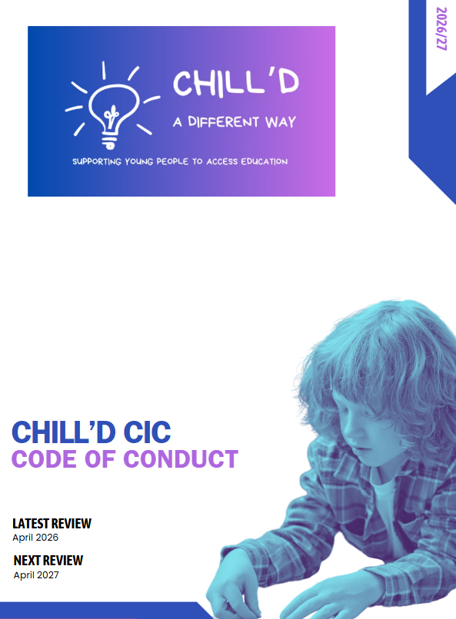

Code of Conduct

Chill’d CIC welcomes all who access their services or communicates with them through any media.
We expect all clients and users, visitors, volunteers, staff to be treated with respect, patience and courtesy.
For the protection of clients and users, visitors, volunteers, and staff, we have a strict policy for personal behaviour and on-line activity for all people in the building or communicating with us by telephone, e-mail or social media.
Chill’d CIC will not tolerate anti-social behaviour or communications to or between clients and users, visitors, volunteers, or staff.
Any person or organisation felt by the Chill’d CIC to be:
- Verbally or physically abusive or aggressive
- Using discriminatory language or behaviour such as racism, sexism, ageism etc.
- Under the influence of alcohol, drugs or other substances.

Any exclusions from groups or services will be decided upon by the directors, they will make the decision as to how long a period of time the exclusion will stand, taking account of all relevant circumstances and the views of other people affected by the behaviour displayed. This may mean services to that person, membership of the organisation, placement with / volunteering role or employment be permanently terminated.

Where the issue is through a source of media that communication will be terminated immediately and should this occur in our dealings with a person from another organisation, the incident will be shared with the organisation, in an appropriate manner. The directors will make any decision about their future involvement with another organisation dependent on the outcome of the other organisations approach and subsequent action to their complaint.

