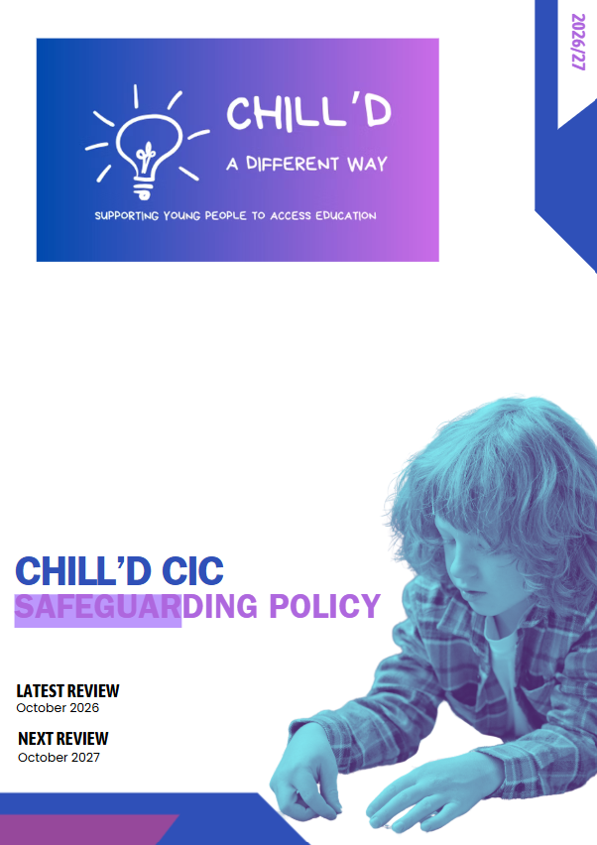

Safeguarding and Child Protection Policy

1. Purpose, scope and legal status
Chill’d CIC is committed to protecting children and young adults from abuse, neglect, exploitation and avoidable harm, and to providing a safe, inclusive, trauma-informed and respectful environment. This policy applies to employees, directors, agency workers, contractors, volunteers, visiting professionals and all delivery locations, including outreach, rented/shared premises, community venues, transport and online contact.
A child is a person under 18. Learners aged 18–25 are adults and are supported under the relevant adult safeguarding, mental capacity and consent framework, as applicable. An Education, Health and Care Plan does not extend the legal definition of a child.
Chill’d CIC is described in the source document as a non-school alternative provision. Keeping Children Safe in Education (KCSIE) 2026 is statutory guidance for schools and colleges and is used here as a safeguarding benchmark; its school-specific legal duties are not automatically imposed on an unregistered provider. The DfE Non-school AP Voluntary National Standards (2025) are currently non-statutory, although commissioning agreements may make specified provisions contractually binding. Working Together to Safeguard Children 2026 informs multi-agency practice, subject to each organisation’s legal status and duties.
Relevant frameworks include the Children Acts 1989 and 2004; Safeguarding Vulnerable Groups Act 2006; Care Act 2014; Mental Capacity Act 2005; Equality Act 2010; Human Rights Act 1998; UK GDPR and Data Protection Act 2018 as amended; Counter-Terrorism and Security Act 2015 where applicable; and local Warwickshire safeguarding partnership procedures. Chill’d CIC will comply with duties applicable to its actual activities and status.

2. Safeguarding contacts and cover
DSL / safeguarding director/governance Lead | Emma Shiers | 07735 045194 | theemmas@chilldcic.com
DSL | Matthew Pike | 07858 761284 | matthew@chilldcic.com
Deputy DSL | Emma Clue | 07549 556681 | theemmas@chilldcic.com
Children’s services / Family Connect | Warwickshire: 01926 414144
LADO | lado@warwickshire.gov.uk | 01926 745376
Adult safeguarding | Warwickshire: 01926 412080; emergency duty team: 01926 886922
Police | 999 emergency; 101 non-emergency
Commissioning school / LA DSL | See individual placement contact schedule – must be completed for every learner
Prevent / Channel | Local referral pathway

Before each delivery day the provider will ensure staff know the on-duty safeguarding lead and escalation arrangements. Where neither DSL nor deputy can be reached, staff must take necessary safeguarding action directly; the absence of a lead must never delay an emergency response or referral.

3. Safeguarding principles and recognising harm
Safeguarding includes offering timely family help and support; protecting children from maltreatment inside and outside the home, in the community and online; preventing impairment of health or development; and taking action so children grow up with safe and effective care. Staff will listen to learners, take disclosures seriously, act without discrimination, and consider contextual risks, additional communication needs and barriers to disclosure.
- Indicators may include physical, emotional or sexual abuse; neglect; domestic abuse and coercive control; child criminal or sexual exploitation, county lines and trafficking; missing episodes; harmful sexual behaviour; child-on-child abuse; bullying and discriminatory abuse; radicalisation; FGM, forced marriage and other honour-based abuse; online grooming and image-based sexual abuse.
- Staff must not assume that absence of disclosure means absence of harm. A child may experience several forms of harm simultaneously.
- Safeguarding responses must be proportionate, culturally sensitive and accessible for learners with SEND, communication needs or disabilities.

4. Governance and responsibilities

Directors / management
- Maintain clear safeguarding accountability, safe recruitment arrangements, sufficient staffing and resources, appropriate premises and outreach risk controls, and regular audit of policy implementation.
- Ensure the DSL has authority, training, time and secure record access; arrange cover and independent handling of allegations about senior leaders.
- Confirm commissioners receive appropriate safeguarding, attendance and placement information; review themes, complaints, incidents and lessons learned.

DSL and deputy
- Coordinate safeguarding concerns, child protection referrals and liaison with the learner’s school, family help practitioners, children’s social care, police and adult safeguarding services as relevant.
- Maintain confidential chronological records, monitor actions and outcomes, review individual risk assessments and ensure information is transferred securely when placements end.
- Lead online safety, Prevent awareness, safer working arrangements, staff support and regular updates; seek advice when referral thresholds are uncertain.

All staff, volunteers and contractors
- Recognise, respond and report concerns immediately; preserve the learner’s words and factual observations; do not investigate allegations or promise confidentiality.
- Take direct action when needed: any member of staff may contact children’s social care, adult safeguarding or police without waiting for DSL permission.
- Follow the code of conduct, professional boundaries, site safety, lone-working and communication arrangements; challenge discriminatory or unsafe practice.

5. Safer recruitment, suitability and SCR
Chill’d CIC will apply role-specific safer recruitment and vetting proportionate to work undertaken, including identity verification, employment history and gaps, references, relevant qualifications, right to work where legally required, and safeguarding-focused interviews. Shortlisted-candidate online searches may be considered as part of a documented, fair process. Health/fitness enquiries must comply with equality law and be confined to lawful, role-relevant purposes.
An appropriate DBS check will be obtained where eligible. Enhanced DBS with Children’s Barred List information is required where the role constitutes regulated activity and eligibility criteria are met. Teaching prohibition, historic directions, Section 128 and overseas professional-standing checks will be considered where applicable to the person, role and setting; they are not blanket checks for every staff member.
Chill’d CIC will maintain a single central record of relevant recruitment checks as recommended by the voluntary standards, recording the check type, date, outcome, evidence verified and role-based ‘N/A’ rationale. DBS certificates have no fixed statutory expiry date; although we will expect these to review these annualy. Original documents and DBS information must be retained only as legally justified.
For agency staff, contractors and external tutors, Chill’d CIC will obtain written assurance of appropriate checks and verify identity on arrival. Volunteers will be assessed for the activity and supervision planned. Where legal DBS referral conditions are met following removal from regulated activity, the DSL will make a referral to DBS; LADO and police processes may also apply.

6. Induction, training and supervision
Before unsupervised contact with learners, staff will receive an induction covering this policy, reporting and escalation routes, allegations and low-level concerns, code of conduct, information sharing, attendance, lone working, online safety, and relevant individual risk assessments. Safeguarding learning will be refreshed at least annually as an organisational expectation, with updates during the year; DSL and deputy training will be maintained at a level appropriate to the role and refreshed in line with local/provider arrangements.
Training will address child-on-child harm, sexual harassment and abuse, exploitation, SEND, trauma-informed practice, Prevent where relevant, adult safeguarding where adults attend, and responding to disclosures. Training and competency records will be maintained.

7. Responding to safeguarding concerns: children under 18
- If immediate danger, urgent medical need or a crime in progress: call 999 and take proportionate action to protect the child.
- Listen calmly, do not ask leading questions, do not investigate, do not promise secrecy, and record the child's words and observed facts as soon as possible.
- Report to the DSL/deputy immediately using the approved safeguarding recording route. https://forms.gle/K1EKpCKcJebPRLjs7 or the QR code on the ID badge.
- The DSL will consider immediate safety, child’s wishes, parent/carer contact, information sharing with the commissioning school and referral to children’s social care or police under local thresholds. Family help/early support may be appropriate where statutory protection thresholds are not met.
- Any staff member may refer directly to children’s social care or police at any time if necessary, including where they disagree with an internal decision or cannot reach the DSL. They should inform the DSL as soon as safe and appropriate.
- Record the concern, rationale, contacts, referrals, feedback, follow-up owner and outcome. Escalate unresolved professional disagreement through the current Warwickshire Safeguarding Children Partnership escalation process.
Parents/carers will normally be informed unless doing so may increase risk, prejudice an investigation or otherwise undermine the child’s safety. Information will be shared lawfully, promptly and on a need-to-know basis; lack of consent must not prevent necessary safeguarding sharing where another lawful basis applies.
Concerns may be raised anonymously. Anonymous reports will be recorded and assessed on their merits, with confidentiality protected as far as possible.

8. Safeguarding learners aged 18–25
An adult learner is not automatically an ‘adult at risk’ because they have SEND, mental health needs or an EHCP. The DSL will assess whether the Care Act 2014 section 42 criteria may be met: the adult has care and support needs, is experiencing or at risk of abuse or neglect, and because of those needs is unable to protect themselves. Concerns may also require police, health, domestic abuse or other services even if section 42 criteria are not met.
- Respond to immediate danger through 999 and obtain urgent medical assistance if required.
- Listen to the adult, explain information sharing and involve them in decisions wherever possible; presume capacity unless assessed otherwise for the specific decision.
- Report promptly to the safeguarding lead and consider adult safeguarding advice/referral through Warwickshire’s current route, or the relevant local authority where the adult is located.
- Consider the Mental Capacity Act 2005 and best-interests process where relevant; do not assume that family members or a school can consent on behalf of an adult.
- Document the adult’s views, risk, legal basis for sharing information, actions, referral and review.
Where incidents involve both children and adults, safeguarding responses will address each person's legal status and needs; parallel child and adult safeguarding referrals may be required.

9. Allegations, transferable risk and low-level concerns
A concern may meet the harm threshold if a person working with children has: (a) harmed or may have harmed a child; (b) possibly committed a criminal offence against or related to a child; (c) behaved towards a child or children in a way indicating a risk of harm; or (d) behaved or may have behaved in a way indicating they may not be suitable to work with children. The fourth criterion can include relevant conduct outside work (‘transferable risk’).
Staff must report concerns immediately to the nominated case manager. The case manager will seek LADO advice promptly, normally within one working day for allegations meeting or potentially meeting the threshold, and follow local arrangements. No internal investigation that could prejudice statutory processes will take place before appropriate consultation. Suspension is not automatic and alternatives must be considered.
Whistleblowing and anonymous reporting routes remain available. Records, referrals, confidentiality and outcomes will follow relevant legal and local guidance.
Case Manager: Emma Shiers
Case Manager for allegations involving Emma Shiers: Emma Clue
Procedure if both Emmas are implicated: Contact LADO directly

10. Child-on-child abuse and harmful sexual behaviour
Chill’d CIC will not dismiss abuse as banter or an inevitable part of growing up. Reports of sexual violence, sexual harassment, bullying, coercion, exploitation, sharing intimate images, upskirting and harmful sexual behaviour will be taken seriously, with immediate consideration of the safety and support needs of everyone involved.
Staff will preserve evidence without forwarding intimate images, inform the DSL and consider police, children’s social care, specialist support and commissioner involvement. Individual safety plans, supervision, separation and educational support will be reviewed without automatically penalising the reporting child. For incidents involving adults aged 18–25, Chill’d will use adult safeguarding, consent, capacity and criminal law frameworks as appropriate.
Concerns about FGM must be referred through safeguarding processes. The specific mandatory police-reporting duty applies to regulated professionals, including teachers as defined in the relevant legislation, who discover that FGM appears to have been carried out on a girl under 18; it does not automatically apply to every AP worker.

11. Online safety, devices and filtering
Online safeguarding includes grooming, bullying, exploitation, coercive control, harmful content, sharing intimate images, and digitally manipulated or AI-generated sexual images/deepfakes. Staff must not create, copy or circulate suspected illegal imagery; they must preserve relevant information safely and seek DSL/police advice.
Chill’d CIC will assess online safety risks at every delivery location, including rented or shared venues and learners’ own devices. Where Chill’d CIC controls devices or networks it will apply appropriate filtering, monitoring, access permissions, incident review and technical support. Where third-party Wi-Fi is used, it will verify safeguards and agree compensating controls; it must not claim that all personal/mobile-data use can be monitored.
Staff will use approved channels for learner communications and will not store safeguarding records or take pupil photographs on personal devices unless a specifically authorised, secure arrangement exists. Learners will receive accessible online safety education.

12. Attendance, absence and missing learners
Chill’d CIC will record attendance for every planned session, and share attendance and absence information promptly with the commissioning school or local authority in accordance with the placement agreement. We aim to do this within the DfE recommended 30 minutes.
Attendance is recorded using ‘Evidence Me’ system and Matthew Pike will communicate with commissioners.
The child’s school retains responsibility for its statutory register where the pupil remains on roll.
Where a child fails to arrive, staff will assess immediate risk, notify the agreed contact promptly, undertake the agreed welfare action and escalate urgent safeguarding concerns without delay. Any mismatch or missing attendance return will be followed up. Patterns of non-attendance will be reviewed with commissioners.

13. Outreach, lone working, transport and site safety
Before each placement, Chill’d CIC will obtain sufficient information about the learner’s safeguarding needs, risks, communication requirements, medical needs and emergency contacts. Individual, location and activity risk assessments will be reviewed when circumstances change.
Outreach and one-to-one sessions will operate under agreed lone-working and check-in/check-out procedures, with staff location, emergency contact, boundaries for home visits, safeguarding escalation and missed check-in response specified. Staff must not enter or remain in unsafe environments and must know when to withdraw and call emergency services.
At hired/shared/community premises, the responsible manager will verify access controls, visitor sign-in and identity, supervision of visitors, toilets/changing arrangements, evacuation and first aid arrangements, safe handover and suitability of any Wi-Fi. Transport arrangements, authorised collection and handover must be agreed for each learner where applicable.

14. Information sharing, records and confidentiality
Safeguarding records will be timely, factual, dated, attributable, securely held and separate from general educational notes where appropriate. Staff will document the child's voice, professional judgement, decisions, rationale, referrals and outcomes. Access will be limited to those who need it.
Information may be shared without consent where necessary and lawful to safeguard a person; practitioners must assess necessity, proportionality, data protection basis, transparency and safety.

15. Professional conduct, complaints and whistleblowing
Staff will maintain professional boundaries, avoid private social-media contact and unauthorised messaging, and follow rules on gifts, physical contact, transport, personal devices, photography and intimate care. Concerns about unsafe practice may be raised to the DSL, deputy, independent case manager, LADO or appropriate statutory agency. The NSPCC whistleblowing advice line (0800 028 0285) is an external option; Protect is an independent whistleblowing charity.
Chill’d CIC provide a clear route for learners and families to raise concerns, including anonymously, and will protect people who report in good faith from victimisation.

16. Equality, SEND and additional vulnerability
Safeguarding arrangements will take account of disability, SEND, care experience, mental health, communication needs, exploitation, domestic abuse, homelessness, young caring roles, EHE and dual-roll status. Staff will avoid discriminatory assumptions and provide reasonable adjustments, accessible communication, advocacy or interpretation where needed. Chill’d CIC will coordinate support with commissioners and relevant professionals, subject to lawful information sharing.

17. Quality assurance, availability and review
Directors and management will review safeguarding incidents, attendance patterns, complaints, allegations, staff training, recruitment checks, online safety, venue risks and multi-agency feedback. This policy will be reviewed at least annually and following significant incidents, changes to guidance, operating model or local procedures.
The approved policy will be made available to commissioners, parents/carers, staff and the public, via the website or on request. Staff will acknowledge the current version and receive updates.

Approval: ______________________ Role: ______________________ Date: ______________________

