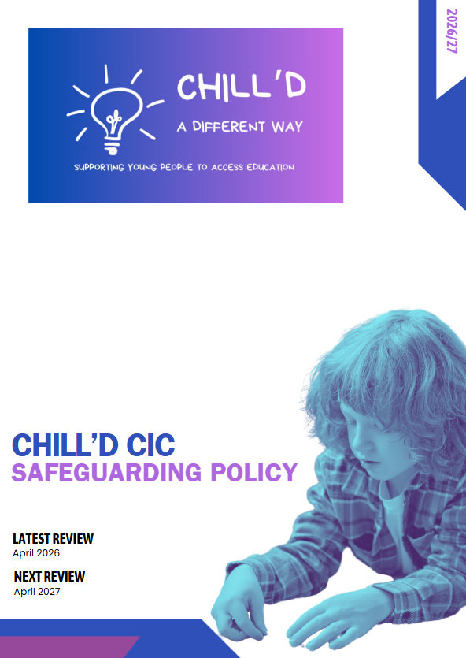

SAFEGUARDING & CHILD PROTECTION POLICY TEMPLATE

1. Policy Statement
This Safeguarding & Child Protection Policy applies to Chill’d CIC, which delivers alternative provision, tutoring, vocational training, mentoring, or other educational activities to children and young people.
Chill’d CIC is committed to:
- Safeguarding and promoting the welfare of all children
- Ensuring that children feel safe, listened to, and valued
- Providing a safe, supportive environment for learners, staff, and visitors
- Working collaboratively with commissioning schools, local authorities, families, and safeguarding partners
This policy complies with:
- Keeping Children Safe in Education (KCSIE 2024)
- Working Together to Safeguard Children (2023)
- Alternative Provision Statutory Guidance (DfE)
- Education Act 2002 (Section 175/157)
- UK GDPR and Data Protection Act 2018
- Prevent Duty (2015)

2. Key Contacts
Role | Name | Contact Details
Designated Safeguarding Lead (DSL) | Emma Shiers | 07735 045194 emmashiers@sky.com
Deputy DSL(s) | Emma Clue | 07549556681 ehc11@hotmail.co.uk
Safeguarding Director / Governance Lead | Emma Shiers | 07735 045194 emmashiers@sky.com
Local Authority MASH / Children’s Services | WCC Family Connect | 01926 414144
Local Authority Designated Officer (LADO) | WCC Family Connect | 01926 414144
Police (non-emergency) | — | 101
Emergency Services | — | 999
Commissioning school safeguarding contacts:
Please refer to appendix
3. Definitions
Children
Anyone under the age of 18.
Safeguarding
Protecting children from maltreatment, preventing impairment, ensuring safe and effective care, and promoting positive outcomes.
Child Protection
Procedures to protect a child who is at risk of significant harm.
Types of Abuse
- Physical abuse
- Emotional abuse
- Sexual abuse
- Neglect
- Domestic abuse
- Child sexual exploitation (CSE)
- Child criminal exploitation (CCE) including county lines
- Online abuse
- Harmful sexual behaviour (HSB)
- Child-on-child abuse
- Honour-based abuse including FGM and forced marriage
- Extremism and radicalisation

4. Roles and Responsibilities
4.1 The Provider Chill’d CIC
Chill’d CIC must:
- Ensure all staff understand and follow this policy
- Prioritise safeguarding across all areas of provision
- Maintain compliance with KCSIE and statutory duties
- Ensure safe physical and online environments for learners
- Share safeguarding information promptly with commissioning schools
4.2 Designated Safeguarding Lead (DSL)
The DSL (named above) must:
- Manage safeguarding concerns and referrals
- Liaise with the local authority, commissioning schools, and external agencies
- Ensure staff receive effective safeguarding training
- Maintain secure and accurate safeguarding records
- Lead on Prevent, online safety, child-on-child abuse, and Early Help
- Ensure risk assessments are completed for all AP learners
4.3 All Staff and Volunteers
Must:
- Read and understand Part 1 of KCSIE
- Report any safeguarding concern immediately
- Maintain professional boundaries
- Model respectful and safe behaviour

5. Safer Recruitment
Chill’d CIC will follow safer recruitment guidance in KCSIE Part 3, including:
- Using a safer recruitment–compliant application form
- Obtaining two references
- Conducting enhanced DBS checks for regulated activity
- Maintaining a Single Central Record (SCR)
- Verifying identity, right to work, and employment history
- Using safeguarding-focused interview questions
If contractors or third-party tutors are used, (Training Provider) must obtain evidence of safer recruitment checks from the employer.

6. Induction and Training
All staff must receive:
- Induction, including policy overview and reporting routes
- Annual safeguarding training
- Prevent Duty training
- Online safety training
- Child-on-child abuse training
- Regular safeguarding updates throughout the year
DSLs require Level 3 DSL training renewed every 2 years.

7. Reporting Concerns
If a child is in immediate danger:
Call 999.
Reporting Procedure:
- Staff report the concern to the DSL immediately using https://forms.gle/K1EKpCKcJebPRLjs7 or the QR code on the ID badge
- DSL assesses the concern using local safeguarding thresholds.
- DSL may:
  - Contact the commissioning school
  - Refer to MASH
  - Initiate Early Help
  - Contact the LADO (if allegation involves staff)
- DSL records all decisions, actions, and outcomes.

8. Allegations Against Staff and Low-Level Concerns
Chill’d CIC will:
- Report all allegations against staff to the LADO within one working day
- Maintain a low-level concerns log
- Follow KCSIE Part 4 procedures
Editable:
Emma Shiers is the person responsible for LADO referrals
9. Child-on-Child Abuse
The provider must have zero tolerance for:
- Bullying
- Sexual harassment or sexual violence
- Upskirting
- Harmful sexual behaviour
- Coercion, initiation, humiliation
Response procedure:
safeguarding form to be completed and reported to the DSL

10. Prevent Duty / Radicalisation
The DSL will act as Prevent lead and must:
- Identify radicalisation risks
- Report concerns to Channel or MASH
- Deliver Prevent training to staff

11. Online Safety
Chill’d CIC will:
- Ensure appropriate filtering and monitoring systems
- Implement acceptable use agreements
- Train learners in safe and appropriate online behaviour
- Establish rules for staff use of devices and communication
- Respond quickly to online safety incidents
Editable:
rented spaces with WIFI will ensure protected measures are set this will be recorded.

12. Attendance, Missing Learners, and AP Reporting Duties
must:
- Record attendance for every session
- Report any absence immediately to the commissioning school
- Follow missing-from-education safeguarding procedures
Editable:
- Attendance system used: evidence me
- Who contacts the commissioning school: Emma Clue - Director
- Timeframe for reporting absence: minimum one hour before session starts

13. Risk Assessments
Chill’d CIC must have:
- A setting-wide safeguarding risk assessment
- Individual learner risk assessments
- Activity-specific risk assessments
- Responsible person: Emma Clue

14. Record Keeping and Data Protection
Records must be:
- Accurate, factual, and chronological
- Stored securely using a secure file system
- Shared appropriately with commissioning schools
- Retained according to statutory requirements

15. Professional Boundaries and Staff Conduct
Chill’d CIC must implement:
- A Code of Conduct
- Clear expectations for communication and personal relationships
- Rules on gifts, transport, social media, and physical contact

16. Safeguarding for Vulnerable Groups
The provider must detail how it supports:
- Learners with SEND
- Looked After Children
- Learners with mental health needs
- Children at risk of exploitation
- Young carers
- EHE or dual-rolled learners
Editable:
safeguarding procedure is implemented

17. Whistleblowing
Staff should report concerns to:
- Whistleblowing Lead: Protect – 020 3117 2520 – independent charity
- Or use the NSPCC Whistleblowing Line: 0800 028 0285

18. Policy Review
This policy will be reviewed annually or earlier if:
- Statutory guidance changes
- There is a significant safeguarding incident
- Operational or organisational changes occur
Last reviewed: April 26
Next review due: April 27
Signed:
Emma Shiers and Emma Clue
Role: Directors/founders
Date: 21/04/26

