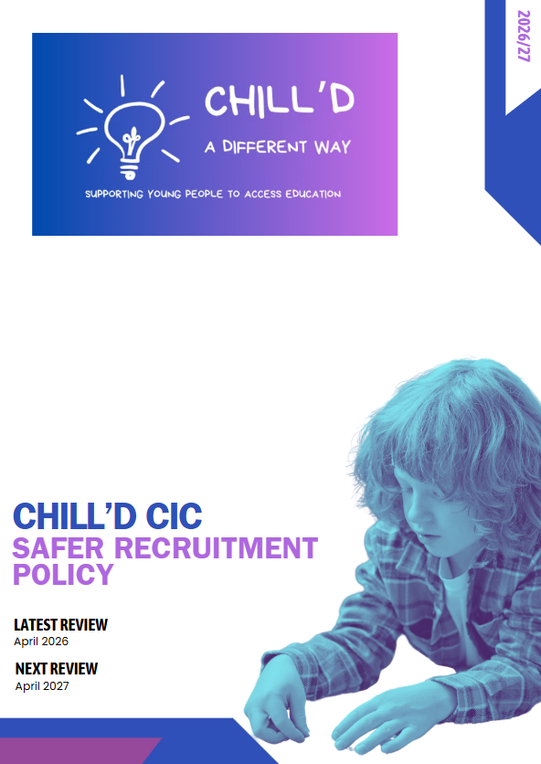

Safer Recruitment Policy
1. Introduction
Chill’d CIC offer alternative provision to students who, for various reasons, are unable to attend mainstream schools full time. These students may have experienced trauma, behavioural difficulties, special educational needs, or other challenges that make them particularly vulnerable. Therefore, a robust safer recruitment policy is paramount to protect them from harm. This policy applies to all staff, including tutors, teaching assistants, support staff, administrative staff, volunteers, and contractors, who have contact with students in our alternative provision.
2. Aims and Objectives
The aims of this policy are to:
- Prevent unsuitable individuals from working with students at Chill’d CIC.
- Deter potential abusers from applying for positions.
- Identify and reject applicants who pose a risk to students.
- Create a culture of vigilance and safeguarding within Chill’d CIC.
- Ensure compliance with relevant legislation and guidance.
The objectives of this policy are to:
- Implement rigorous recruitment procedures.
- Provide comprehensive training to staff on safer recruitment practices.
- Conduct thorough background checks on all applicants.
- Monitor staff performance and address any concerns promptly.
- Regularly review and update the policy to reflect best practices and KCSIE.
3. Roles and Responsibilities
- Contract Managers: Responsible for ensuring that the alternative provision has a robust safer recruitment policy in place and that it is effectively implemented.
- Head of centre: Responsible for overseeing the implementation of the safer recruitment policy and ensuring that all staff are aware of their responsibilities.
- Designated Safeguarding Lead (DSL): Responsible for providing advice and support to staff on safeguarding matters and for liaising with external agencies.
- Recruitment Panel: Responsible for conducting the recruitment process in accordance with this policy.
- All Staff: Responsible for adhering to this policy and for reporting any concerns about the safety or well-being of students.

4. Recruitment Process
The recruitment process will consist of the following stages:
4.1. Advertisement
- Advertisements will clearly state Chill’d CIC commitment to safeguarding and promoting the welfare of children.
- The job description will outline the responsibilities of the role in relation to safeguarding.
- Advertisements will encourage applications from a diverse range of candidates.
4.2. Application Form
- The application form will require applicants to provide detailed information about their qualifications, experience, and employment history.
- Applicants will be asked to declare any criminal convictions, cautions, or reprimands.
- Applicants will be required to provide the names and contact details of at least two referees.
- The application form will include a statement requiring applicants to confirm that they are not disqualified from working with children.
4.3. Shortlisting
- The shortlisting process will be conducted by a panel of at least two people.
- The panel will carefully review all applications and assess candidates against the essential criteria outlined in the job description.
- Any gaps in employment history or inconsistencies in the application will be investigated.
4.4. Interview
- The interview panel will include at least one person who has received safer recruitment training.
- Interview questions will be designed to assess the candidate's suitability to work with vulnerable students and their understanding of safeguarding issues.
- Candidates will be asked about their motivation for working in alternative provision and their experience of working with challenging behaviour.
- The panel will explore any concerns raised during the shortlisting process.
4.5. References
- References will be obtained from the candidate's current and previous employers.
- References will be verified to ensure their authenticity.
- Referees will be asked specific questions about the candidate's suitability to work with children, their safeguarding knowledge, and their ability to manage challenging behaviour.
- Any concerns raised in the references will be investigated.
4.6. Disclosure and Barring Service (DBS) Checks
- All successful candidates will be required to undergo an enhanced DBS check with barred list information.
- Chill’d CIC will adhere to the DBS Code of Practice.
- The DBS check will be reviewed by a designated person who has received appropriate training.
- Any information revealed by the DBS check will be carefully considered in relation to the candidate's suitability to work with students.
4.7. Other Checks
- Right to work in the UK will be verified.
- Qualifications will be verified.
- Prohibition checks will be conducted for teaching staff.
- Online searches may be conducted to identify any publicly available information that may be relevant to the candidate's suitability to work with children.
4.8. Induction
- All new staff will receive a comprehensive induction, including training on safeguarding, child protection, and behaviour management.
- Staff will be provided with a copy of this policy and other relevant safeguarding policies.
- Staff will be informed of their responsibilities in relation to safeguarding and child protection.
5. Ongoing Monitoring and Training
- All staff will receive regular safeguarding training, including updates on relevant legislation and guidance.
- Staff performance will be monitored through regular supervision and appraisal.
- Any concerns about staff conduct or competence will be addressed promptly and appropriately.
- Chill’d CIC will maintain a culture of vigilance and encourage staff to report any concerns about the safety or well-being of students.
6. Allegations Against Staff
- Chill’d CIC will have a clear procedure for dealing with allegations against staff, in accordance with statutory guidance.
- Allegations will be investigated promptly and thoroughly.
- The DSL will liaise with the local authority designated officer (LADO) in relation to any allegations that meet the threshold for referral.
- Chill’d CIC will cooperate fully with any investigations conducted by external agencies.
7. Review
This policy will be reviewed annually, or more frequently if required, to ensure that it remains effective and compliant with relevant legislation and guidance. The review will be conducted by the Head of centre and DSL.

