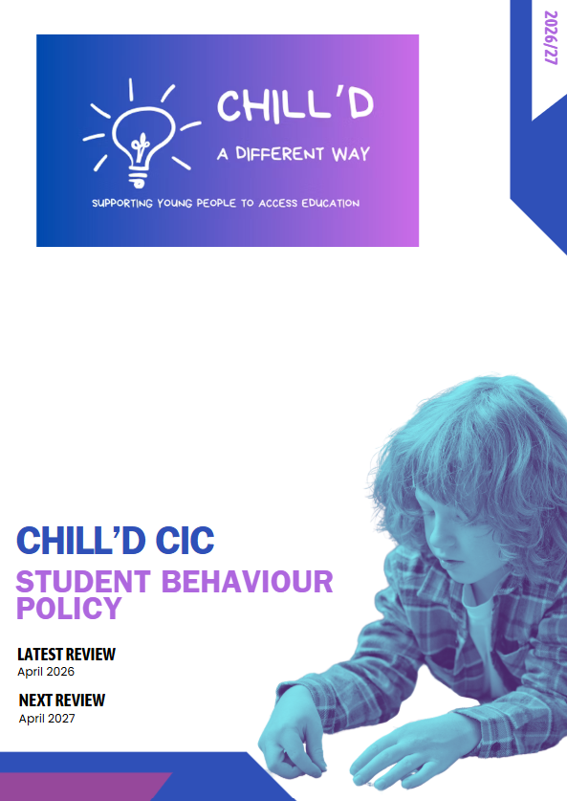
Behaviour Policy
This document outlines the Behaviour Policy for Chill’d CIC, aimed at fostering a positive and conducive learning environment for all students. The policy is designed to promote good behaviour, ensure safety, and support the personal and academic development of each learner. By establishing clear expectations and consequences, we aim to create a respectful and inclusive atmosphere that encourages students to engage fully in their educational journey.
1. Purpose
The purpose of this Behaviour Policy is to:
- Establish a clear framework for expected behaviour within the training environment.
- Promote a culture of respect, responsibility, and resilience among students.
- Provide guidance for staff on managing behaviour effectively and consistently.
- Outline the procedures for addressing inappropriate behaviour.
2. Expected Behaviour
Chill’d CIC expect all students to:
- Show respect to themselves, peers, staff, animals and the learning environment.
- Engage actively in all training activities and discussions.
- Take responsibility for their actions and choices.
- Follow instructions from staff promptly and courteously.
- Support their peers and contribute positively to group dynamics.
3. Staff Responsibilities
Staff members are responsible for:
- Modelling positive behaviour and setting a good example.
- Creating a safe and supportive learning environment.
- Establishing clear rules and expectations for behaviour.
- Addressing any incidents of inappropriate behaviour promptly and fairly.
- Providing support and guidance to students who may struggle with behaviour.
4. Consequences of Inappropriate Behaviour
Inappropriate behaviour will be addressed through a tiered approach, which may include:
- Verbal Warning: A reminder of expected behaviour and the opportunity to correct actions.
- Reflection Time: A designated period for the student to reflect on their behaviour and its impact.
- Parental/Guardian Involvement: Communication with parents or guardians to discuss concerns and strategies for improvement.
- Behaviour Support Plan: Development of a tailored plan to support the student in making positive changes.
- Temporary Exclusion: In severe cases, a temporary exclusion from the training environment may be necessary.
Throughout this process Chill’d CIC will involve appropriate stakeholders including any contract managers and we will ensure that we follow any contractual obligations within our reporting methods.
5. Support for Positive Behaviour
To encourage positive behaviour, we will:
- Recognise and celebrate achievements and good behaviour through rewards and incentives.
- Provide training and resources for staff on effective behaviour management strategies.
- Offer support services for students who may require additional assistance.
6. Review and Monitoring
This Behaviour Policy will be reviewed annually to ensure its effectiveness and relevance. Feedback from students, staff, and parents/carers will be considered in the review process to continuously improve our approach to behaviour management.
Conclusion
Our Behaviour Policy is a vital component of our commitment to providing a safe and effective learning environment. By working together as a community, we can support each student in achieving their full potential while fostering a culture of respect and responsibility.

