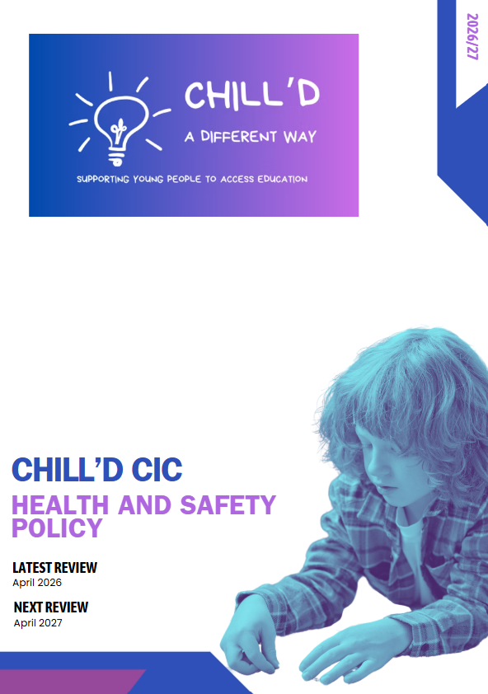
. Introduction
Chill’d CIC is committed to providing a safe and healthy environment for all students, staff, visitors, and contractors. This policy sets out the framework for managing health and safety risks within the provision and ensuring compliance with all relevant legislation, including but not limited to the Health and Safety at Work etc. Act 1974, the Management of Health and Safety at Work Regulations 1999, and the Education (Independent School Standards) Regulations 2014 (as applicable).
2. Policy Statement
The governing body and management team of Chill’d CIC recognise their responsibility to:
- Provide a safe and healthy learning and working environment.
- Prevent accidents and work-related ill health.
- Comply with all relevant health and safety legislation and guidance.
- Provide adequate resources for health and safety.
- Consult with staff and students on health and safety matters.
- Regularly review and update this policy.
3. Responsibilities
3.1 Management Team
The Management Team has overall responsibility for health and safety within the provision and will:
- Ensure that adequate resources are available for health and safety.
- Monitor the implementation of this policy.
- Receive reports on health and safety performance.
3.2 Head of Centre
The Head of Centre is responsible for the day-to-day management of health and safety and will:
- Implement this policy.
- Ensure that risk assessments are carried out and reviewed regularly.
- Provide appropriate training and information to staff.
- Investigate accidents and incidents.
- Liaise with relevant external agencies.
3.3 Designated Health and Safety Officer
Emma Clue is the designated Health and Safety Officer and will:
- Advise the Head of Centre on health and safety matters.
- Assist in the development and implementation of health and safety procedures.
- Carry out regular inspections of the premises.
- Maintain records of accidents, incidents, and risk assessments.
3.4 All Staff
All staff are responsible for:
- Following this policy and all relevant procedures.
- Taking reasonable care for their own health and safety and that of others.
- Reporting any hazards or concerns to the Designated Health and Safety Officer or Head of Centre.
- Cooperating with management on health and safety matters.
- Participating in health and safety training.
3.5 Students
Students are responsible for:
- Following instructions and rules relating to health and safety.
- Taking reasonable care for their own health and safety and that of others.
- Reporting any hazards or concerns to a member of staff.
3.6 Visitors and Contractors
Visitors and contractors are responsible for:
- Adhering to the health and safety rules of the provision.
- Reporting to reception upon arrival.
- Following instructions given by staff.
- Ensuring their activities do not endanger themselves or others.
4. Risk Assessment
Risk assessments will be carried out for all activities and areas within the provision to identify potential hazards and implement appropriate control measures. These assessments will be:
- Conducted by competent persons.
- Documented and regularly reviewed (at least annually or more frequently if circumstances change).
- Communicated to all relevant staff and students.
- Prioritised based on the level of risk.
Specific risk assessments will be conducted for:
- Fire safety
- Manual handling
- COSHH (Control of Substances Hazardous to Health)
- Educational visits
- Use of machinery and equipment
- Specific student needs (e.g., medical conditions, behavioural issues)
- Display Screen Equipment (DSE)
- Specific activities
5. Fire Safety
The provision will comply with all relevant fire safety legislation and guidance. This includes:
- Maintaining a fire risk assessment.
- Providing adequate fire detection and alarm systems.
- Ensuring that fire exits are clear and accessible.
- Conducting regular fire drills.
- Providing fire safety training to staff.
- Maintaining fire extinguishers and other fire-fighting equipment.
6. First Aid
The provision will ensure that:
- Adequate first aid provision is available.
- Sufficient numbers of trained first aiders are available.
- First aid kits are readily accessible and adequately stocked.
- Records are kept of all first aid treatment.

7. Accident Reporting
All accidents and incidents, including near misses, must be reported to the Designated Health and Safety Officer or Head of Centre as soon as possible. An accident report form must be completed and investigated to identify the cause of the accident and prevent recurrence. Records of all accidents and incidents will be maintained.
8. Training
The provision will provide appropriate health and safety training to all staff, including:
- Induction training for new staff.
- Specific training related to their roles and responsibilities.
- Regular refresher training.
- Training on specific hazards and risks.
9. Monitoring and Review
This policy will be regularly monitored and reviewed to ensure its effectiveness and compliance with relevant legislation. The review will include:
- An analysis of accident and incident data.
- Feedback from staff and students.
- Updates to legislation and guidance.
The policy will be reviewed at least annually or more frequently if circumstances change.
10. Specific Hazards and Control Measures
This section outlines specific hazards that may be present in Chill’d CIC and the control measures in place to mitigate these risks.
- Behavioural Issues: Risk assessments will be conducted for students with challenging behaviour, and appropriate support plans will be implemented. Staff will receive training on managing challenging behaviour.
- Manual Handling: Staff will be trained in safe manual handling techniques. Mechanical aids will be provided where possible.
- COSHH: Hazardous substances will be stored and used safely, in accordance with COSHH regulations. Risk assessments will be conducted for all hazardous substances.
- Educational Visits: Thorough risk assessments will be conducted for all educational visits, and appropriate safety measures will be implemented. Parental/Guardian consent will be obtained.
- Premises Security: Measures will be in place to ensure the security of the premises, including controlled access and CCTV.
- Online Safety: Measures will be in place to ensure online safety, including internet filtering and monitoring. Students will be educated about online safety.
11. Communication and Consultation
The provision will ensure that health and safety information is effectively communicated to all staff, students, visitors, and contractors. This will be achieved through:
- Displaying this policy in a prominent location.
- Providing health and safety information in staff handbooks and student guides.
- Holding regular staff meetings to discuss health and safety matters.
- Consulting with staff and students on health and safety issues.
12. Policy Dissemination
This policy will be made available to all staff, students, parents/carers, visitors, and contractors. It will be displayed prominently on the provision's website and in key locations within the building.
13. Contact Information
For any health and safety concerns, please contact:
- Emma Clue 07549 556681 contact@chilldcic.com
This policy is a living document and will be reviewed and updated regularly to ensure its continued effectiveness.

