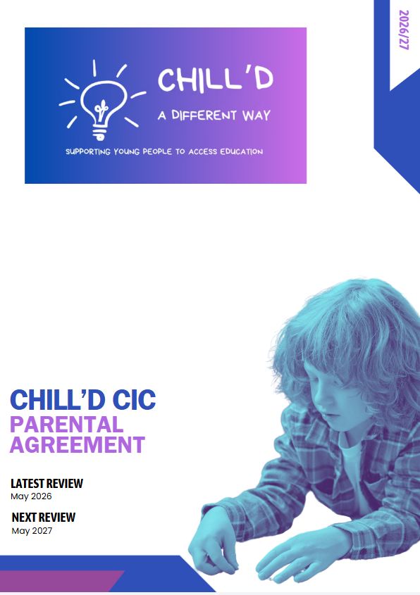

Parental Partnership Agreement
Chill’d CIC Support Agreement
At Chill’d CIC, we believe that the best outcomes for young people happen when staff, parents/carers, and students work together positively and consistently.
This agreement outlines how we can support one another to help your child succeed socially, emotionally, and academically.

Our Commitment to Your Young Person
We will:
- Provide a safe, supportive, and respectful environment.
- Treat all students fairly and with dignity.
- Support your young person’s emotional wellbeing and personal development.
- Encourage positive behaviour and celebrate achievements.
- Communicate regularly regarding progress, attendance, behaviour, and concerns.
- Work collaboratively with parents/carers and outside agencies where appropriate.
- Offer appropriate interventions and support strategies tailored to your young person’s needs.

Parent/Carer Commitment
As a parent/carer, I agree to:

Attendance & Punctuality
- Ensure my young person attends regularly and arrives on time.
- Inform the provision as early as possible if my young person is absent.
- Understand that my young person, legally has to be engaging in some form of education. Failure to achieve an average of 80% attendance rate may result in loss of placement with Chill’d CIC

Communication
- Maintain respectful communication with staff at all times.
- Attend meetings, reviews, and discussions regarding my young person where possible.
- Share relevant information that may affect my young person’s wellbeing or education.
Support at Home
- Encourage positive behaviour, respect, and engagement with learning.
- Support the provision’s expectations, routines, and behaviour policies.
- Reinforce the importance of education, attendance, and effort.
Partnership
- Work collaboratively with staff to address concerns or difficulties.
- Support agreed strategies and interventions put in place for my young person.
- Encourage my young person to take responsibility for their actions and progress.

Student Commitment
The student agrees to:
- Attend regularly and arrive ready to learn.
- Treat staff and peers respectfully.
- Follow instructions and behaviour expectations.
- Try their best and ask for help when needed.
- Take responsibility for their choices and actions.

Working Together
We understand that challenges may arise. Our priority is always to work together constructively and find solutions that support the young person’s success.
Where concerns occur, we will aim to:
- Communicate openly and honestly.
- Resolve issues respectfully and promptly.
- Focus on the best interests of the student at all times.

Agreement
By signing below, we confirm our commitment to working together positively to support the student’s progress, wellbeing, and future success.
Name | Signature | Date
Parent/Carer
Student
Staff Representative

